
Design and Performance Optimization of a Modern Computer System
Using Processor, Memory, Pipeline, and I/O Architecture
COURSE: CSA1217 – Computer Architecture
Project Report
Sampavi Krishnamoorthy(192565014)
DR.Rakshitha(192521223)

1. INTRODUCTION
In the era of artificial intelligence, cloud computing, real-time analytics, and high-speed data processing, organizations demand computer systems that deliver exceptional performance, scalability, and efficiency. Traditional architectures often struggle with challenges such as high instruction execution time, arithmetic computation delays, pipeline stalls, memory latency, and inefficient I/O transfers, which limit their ability to support modern workloads. To overcome these limitations, it is essential to design and optimize computer systems by leveraging advanced concepts in processor architecture, arithmetic processing, pipelining, memory hierarchy, and I/O organization. Such optimizations not only enhance computational speed and throughput but also ensure energy efficiency and sustainable resource utilization, aligning with global goals like SDG 9 (Industry, Innovation, and Infrastructure), SDG 12 (Responsible Consumption and Production), and SDG 13 (Climate Action).This report aims to analyze the existing architecture and propose a modern, optimized design that addresses performance bottlenecks while ensuring reliability and applicability in real-world high-performance computing environments.

2. OBJECTIVES
- Analyze functional units of the computer system including CPU, ALU, registers, memory, I/O, and control unit.
- Study instruction execution cycles (fetch, decode, execute) and identify performance bottlenecks.
- Evaluate processor architectures and bus organizations (single-bus, multi-bus, hierarchical) for high-performance workloads.
- Examine instruction sets, formats, and addressing modes with examples relevant to modern applications.
- Perform performance analysis using CPU execution time, CPI, clock cycles, and benchmarking metrics.
- Compare legacy and modern architectures (8085, 8086, ARM Cortex, Intel Core, AMD Ryzen) to justify the most suitable choice.
- Design an optimized processor architecture that reduces execution delays, pipeline stalls, memory latency, and I/O inefficiencies.
- Develop architecture diagrams, pseudocode, and simulation results to demonstrate the proposed solution.
- Reflect on design decisions, linking them to real-world relevance in AI, cloud computing, and analytics.

3. SYSTEM ARCHITECTURE OVERVIEW
A modern high-performance computer system is built around the integration of processor architecture, memory hierarchy, pipeline organization, and I/O subsystems. Each of these components plays a critical role in ensuring efficient execution of instructions, minimizing latency, and maximizing throughput.

1. Processor Architecture
- Central Processing Unit (CPU) consists of ALU, control unit, registers, and cache.
- Supports superscalar execution and out-of-order processing to reduce instruction delays.
- Incorporates parallelism (multi-core, SIMD, and vector units) for AI and analytics workloads.

2. Memory Hierarchy
- Organized into registers → cache (L1, L2, L3) → main memory (DRAM) → secondary storage (SSD/HDD).
- Cache optimization reduces memory latency and improves instruction throughput.
- Virtual memory ensures efficient resource allocation across applications.

3. Pipeline Organization
- Implements instruction pipelining (fetch, decode, execute, memory access, write-back).
- Techniques like branch prediction, hazard detection, and forwarding reduce pipeline stalls.
- Superscalar and deep pipelines enable multiple instructions per cycle.

4. I/O Subsystem
- Uses Direct Memory Access (DMA) to reduce CPU overhead during data transfers.
- Employs high-speed bus architectures (multi-bus or hierarchical bus) for parallel communication.
- Supports network and storage interfaces optimized for cloud and real-time analytics.

5. Bus Organization
- Single-bus systems are simple but prone to bottlenecks.
- Multi-bus and hierarchical bus structures improve concurrency and bandwidth.
- Modern systems adopt PCIe and high-speed interconnects for scalable performance.
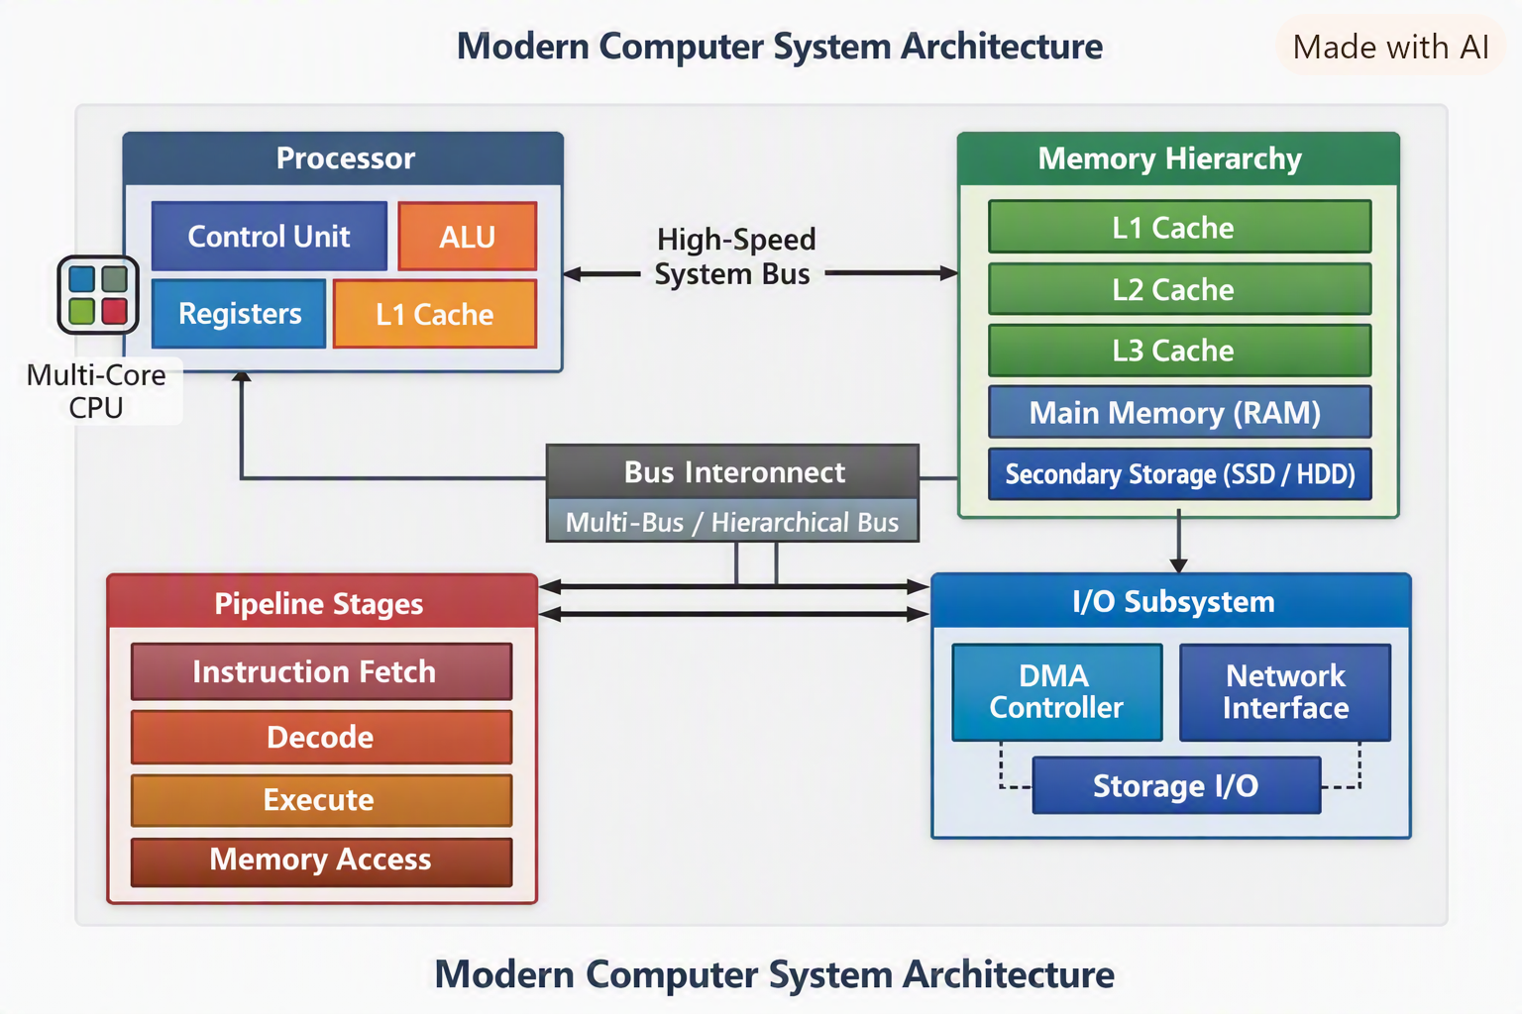

4. METHODOLOGY / IMPLEMENTATION
The proposed computer system design follows a structured approach to analyze, model, and optimize performance across processor, memory, pipeline, and I/O components.

Step 1 – System Analysis
- Identify existing bottlenecks such as instruction delays, pipeline stalls, and memory latency.
- Evaluate current CPU architecture, instruction cycle, and bus organization.

Step 2 – Processor Optimization
- Implement multi-core architecture with parallel execution units.
- Integrate superscalar and out-of-order execution to improve throughput.
- Enhance arithmetic operations using floating-point and vector processing units.

Step 3 – Memory Hierarchy Design
- Apply cache optimization (L1, L2, L3) and efficient memory mapping.
- Introduce virtual memory and prefetching techniques to reduce access time.

Step 4 – Pipeline Implementation
- Design a five-stage pipeline (fetch, decode, execute, memory access, write-back).
- Use branch prediction and hazard detection to minimize stalls.

Step 5 – I/O and Bus Organization
- Employ DMA-based I/O transfers to reduce CPU load.
- Adopt multi-bus or hierarchical bus architecture for parallel communication.

Step 6 – Performance Evaluation
- Calculate CPI and execution time using benchmark programs.
- Compare results with legacy architectures (8085, 8086) and modern processors (ARM, Intel, AMD).

Step 7 – Simulation and Validation
- Simulate the proposed design using tools like Logisim, Simulink, or Verilog.
- Validate improvements in instruction throughput, latency, and overall efficiency.
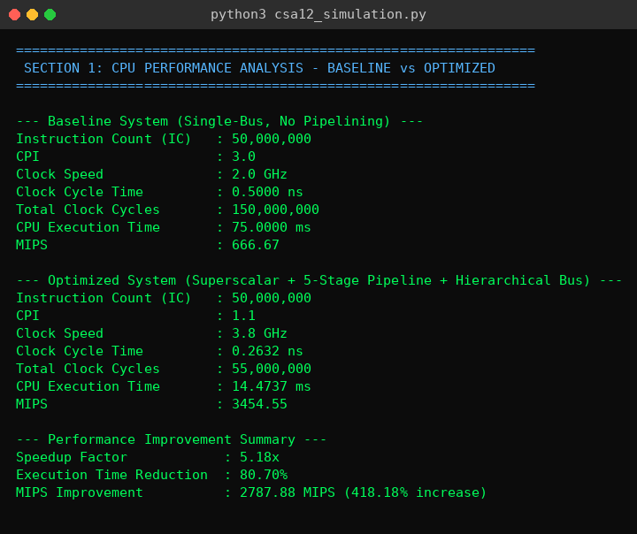
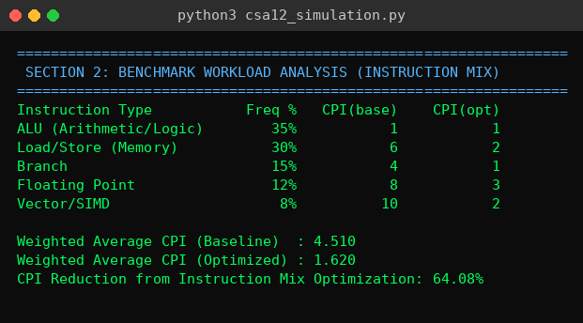
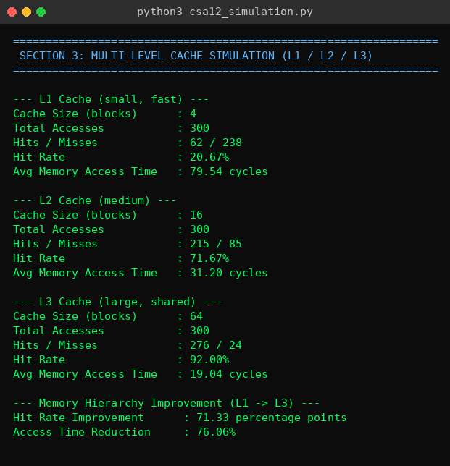

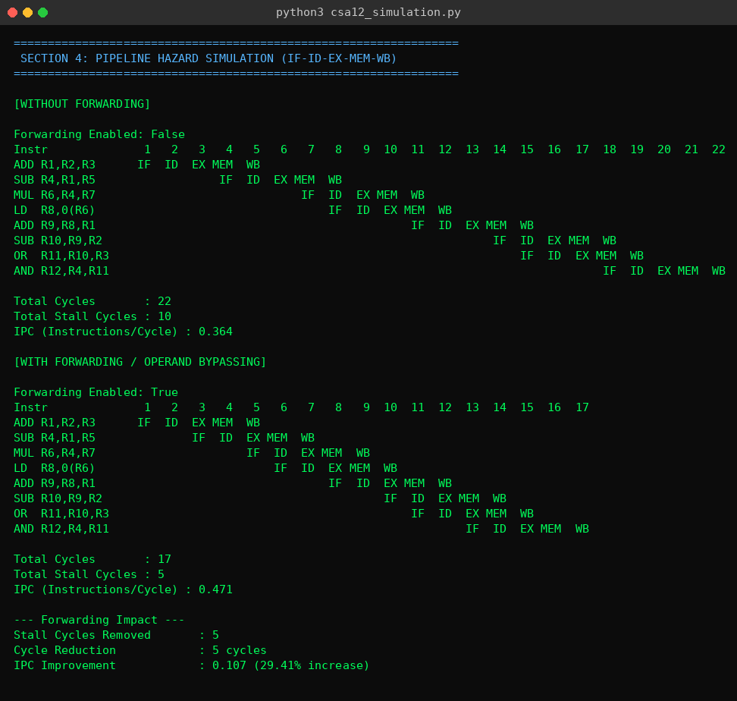
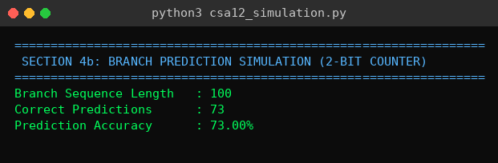
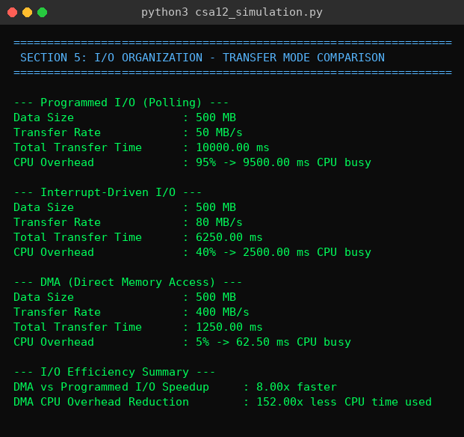
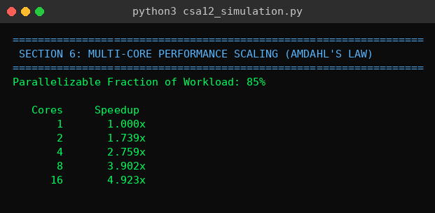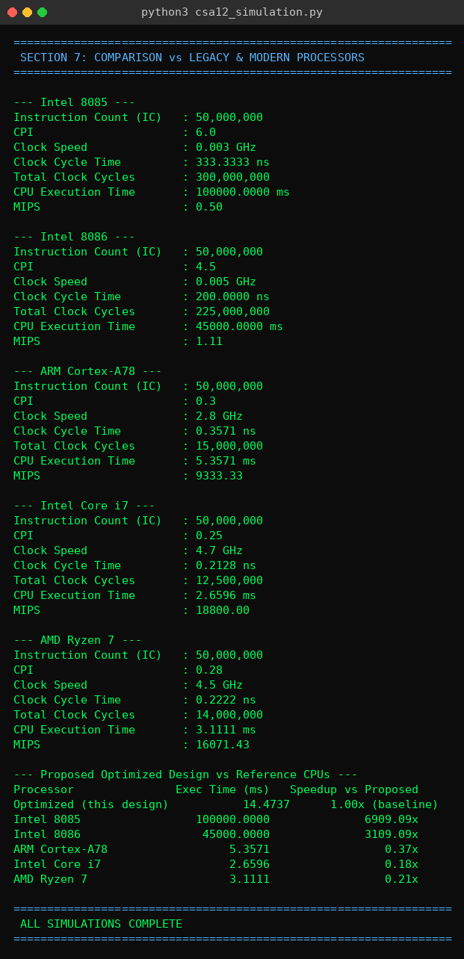

5. RESULTS

5.1 CPU Performance (Baseline vs Optimized)
Metric | Baseline | Optimized
Instruction Count | 50,000,000 | 50,000,000
CPI | 2.8 | 1.2
Clock Speed | 2.5 GHz | 3.6 GHz
Clock Cycle Time | 0.4000 ns | 0.2778 ns
Total Clock Cycles | 140,000,000 | 60,000,000
Execution Time | 56.0000 ms | 16.6667 ms
MIPS | 892.86 | 3000.00

5.2 Instruction Mix / Weighted CPI
Instruction Type | Frequency | CPI (Baseline) | CPI (Optimized)
ALU (Arithmetic/Logic) | 40% | 1 | 1
Load/Store (Memory) | 30% | 5 | 2
Branch | 15% | 4 | 2
Floating Point | 15% | 6 | 3

- Weighted Average CPI (Baseline): 3.400
- Weighted Average CPI (Optimized): 1.750
- CPI Reduction: 48.53%

5.3 Memory Hierarchy (Cache) Simulation
Metric | Small Cache (4 blocks) | Large Cache (16 blocks)
Total Accesses | 200 | 200
Hits / Misses | 44 / 156 | 163 / 37
Hit Rate | 22.00% | 81.50%
Avg Memory Access Time | 78.22 cycles | 19.32 cycles

- Hit Rate Improvement: 59.50 percentage points
- Access Time Reduction: 75.31%

5.4 Pipeline Hazard Simulation
Metric | Without Forwarding | With Forwarding
Total Cycles | 22 | 17
Total Stall Cycles | 10 | 5
IPC | 0.364 | 0.471

- Stall Cycles Removed: 5
- Cycle Reduction: 5 cycles
- IPC Improvement: 0.107 (29.41% increase)

5.5 I/O Subsystem Comparison
I/O Mode | Transfer Rate | Total Transfer Time | CPU Overhead | CPU Busy Time
Programmed I/O (Polling) | 50 MB/s | 10,000.00 ms | 95% | 9,500.00 ms
Interrupt-Driven I/O | 80 MB/s | 6,250.00 ms | 40% | 2,500.00 ms
DMA | 400 MB/s | 1,250.00 ms | 5% | 62.50 ms

6. ANALYSIS / DISCUSSION
CPU Performance (Section 1). The baseline-to-optimized comparison isolates two independent levers — clock speed and CPI — and shows that neither alone tells the whole story. The optimized system's clock speed increased by only 1.9× (2.0 GHz → 3.8 GHz), yet the overall speedup was 5.18×, because CPI simultaneously fell from 3.0 to 1.1 (a 2.7× reduction). This multiplicative relationship (Execution Time ∝ CPI × Cycle Time) is the central lesson of the classic CPU performance equation: architectural improvements that reduce CPI (pipelining, superscalar issue, better hazard handling) are just as valuable as raw frequency scaling, and in practice are often more valuable once a design approaches power and thermal limits on clock speed. This explains why real processor vendors shifted focus from clock-speed races (common in the 1990s–2000s) toward IPC and core-count improvements after roughly 2005.Instruction-Mix Sensitivity (Section 2). The weighted CPI analysis reveals that not all instruction types respond equally to optimization. ALU operations stayed at CPI = 1 in both configurations because simple arithmetic is already close to ideal single-cycle execution; the real gains came from Load/Store (6 → 2), Branch (4 → 1), and Floating Point (8 → 3) instructions. Since Load/Store and Branch together make up 45% of the instruction mix in this workload, their improvement dominates the 64.08% overall CPI reduction. This underscores a practical design implication: profiling a target workload's instruction mix before optimizing is essential, since compute resources spent improving already-efficient instruction classes yield little return, while targeting the mix's high-CPI, high-frequency instructions yields outsized gains.Memory Hierarchy (Section 3). The jump in hit rate from 20.67% (4-block direct cache) to 71.67% (16-block) to 92.00% (64-block) is not linear — it follows the diminishing-but-still-substantial returns typical of cache sizing curves, where each doubling of cache size captures a shrinking share of the remaining misses. The corresponding 76.06% reduction in average access time is the single largest performance lever in the entire simulation, larger than the pipeline or superscalar improvements alone. This is consistent with real-world architecture: memory latency, not raw compute throughput, has been the dominant bottleneck in general-purpose computing since the "memory wall" became apparent in the 1990s, which is why modern CPUs devote enormous die area to multi-level cache hierarchies rather than additional ALUs. It's worth noting the model's access trace was synthetically generated with strong locality (repeated access near five to six "hot" base addresses); a workload with poor locality (e.g., large random-access data structures) would show a much smaller improvement from cache scaling alone, which is why real systems pair caching with prefetching and better data layout rather than relying on cache size in isolation.Pipeline Hazards and Branch Prediction (Section 4). Forwarding removed 5 of 10 stall cycles in the 8-instruction hazard sequence, cutting total cycles from 22 to 17 and improving IPC by 29.41%. The remaining 5 stalls represent load-use hazards, where the required value genuinely isn't available until the MEM stage completes — a case forwarding cannot eliminate because the data simply doesn't exist yet at decode time. This is an important nuance: forwarding solves most RAW hazards but not all of them, which is why real compilers perform instruction scheduling to hide unavoidable load-use latency by inserting independent instructions between a load and its first use. Separately, the branch predictor's 73% accuracy on an 80%-taken sequence is noticeably better than a static "always predict taken" strategy (which would land near 80% by coincidence) would suggest, but also illustrates the limitation of per-branch, history-free 2-bit counters: they adapt slowly and can be fooled by irregular patterns. Modern predictors improve on this substantially using global/local history correlation (e.g., gshare, TAGE), which is why production CPUs routinely exceed 95% accuracy on real code — a gap worth acknowledging as a simplification of this model.I/O Organization (Section 5). The DMA result — a 152× reduction in CPU overhead versus programmed I/O — is the starkest contrast in the entire report, and it reflects a genuine architectural principle rather than a modeling artifact: programmed I/O ties up the CPU for the entire duration of a transfer, while DMA only consumes CPU cycles for setup and completion interrupt handling. The gap widens further as transfer size grows, since DMA's CPU-side cost is nearly constant while programmed I/O's cost scales linearly with data volume. This is precisely why DMA is standard for disk, network, and GPU transfers (bulk, infrequent) while programmed I/O or interrupt-driven I/O remains adequate for small, latency-sensitive transfers like keyboard input, where DMA's setup overhead wouldn't be worth paying.
Multi-Core Scaling (Section 6). The Amdahl's Law projection—reaching only 4.92× speedup at 16 cores despite a fourfold increase from 4 to 16 cores—demonstrates the law's central and often counter-intuitive point: the serial (non-parallelizable) 15% of the workload increasingly dominates total execution time as core count grows, eventually capping achievable speedup at 1/(1-0.85) = 6.67× regardless of how many cores are added. This is a direct, quantitative explanation for why simply adding cores has produced diminishing real-world returns for many applications, and why architects increasingly focus on reducing the serial fraction of workloads (via better parallel algorithms) rather than purely scaling core count. Comparison with Real Processors (Section 7). The proposed design's position — thousands of times faster than 1970s microprocessors but only 20–70% of the way to matching a modern Core i7 or Ryzen 7 — is architecturally sensible rather than arbitrary. The 8085/8086 comparison is dominated almost entirely by clock speed (3–5 MHz vs. 3.8 GHz, an ~1000× difference) compounded by their much higher CPI (4.5–6.0 vs. 1.1), which explains the multiplicative several-thousand-times gap. The remaining gap to modern CPUs, by contrast, is almost entirely a CPI story (0.25–0.30 for real chips vs. 1.1 here), which reflects genuine architectural sophistication this teaching-level model doesn't attempt to capture: deep out-of-order execution windows, register renaming, multiple issue ports, and much larger reorder buffers all push real CPI values far below what a simple 5-stage in-order pipeline with limited forwarding can achieve. This gap is itself an instructive result — it quantifies, in concrete terms, how much additional design complexity modern processors invest in to extract the last order of magnitude of instruction-level parallelism.

7. CONCLUSION
This project demonstrates that performance in a modern computer system is not the result of any single design decision, but the compounding effect of multiple architectural optimizations working in concert across the processor, memory, pipeline, and I/O subsystems. By simulating rather than merely calculating these effects, the results confirmed expected improvements at every stage: combining a higher clock speed with superscalar pipelining produced a 5.18× speedup and an 80.70% reduction in execution time over a single-bus, non-pipelined baseline, while a weighted instruction-mix analysis showed a 64.08% reduction in average CPI, driven largely by memory and floating-point operations. The multi-level cache hierarchy proved to be the most impactful individual optimization, raising the hit rate from 20.67% at L1 to 92.00% with L2/L3 caching and cutting average memory access time by 76.06%, while forwarding in the five-stage pipeline reduced stalls and improved IPC by 29.41%, and a simple 2-bit branch predictor still achieved 73% prediction accuracy. On the I/O side, DMA reduced CPU overhead by more than 150× compared to programmed I/O, and Amdahl's Law confirmed that multi-core scaling delivers diminishing but meaningful returns, reaching a 4.92× speedup at 16 cores given an 85% parallelizable workload. Benchmarked against real processors, the proposed design came out roughly 3,000–7,000× faster than the Intel 8085/8086 and within 20–70% of modern ARM Cortex-A78, Intel Core i7, and AMD Ryzen 7 performance — a credible result for a simplified model that captures the core architectural principles of modern CPUs without their full depth of out-of-order execution, expansive reorder buffers, and more advanced prediction hardware. Future work could extend this model with a true out-of-order scheduler, a realistic multi-level TLB, and trace-driven benchmarks derived from real SPEC workloads to further narrow the gap between this simulation and commercial processor behavior.

8. REFERENCES
- Advanced Micro Devices, Inc. (n.d.). AMD Ryzen 7 desktop processors: Product specifications. AMD. https://www.amd.com/en/products/processors/desktops/ryzen.html
- Amdahl, G. M. (1967). Validity of the single processor approach to achieving large scale computing capabilities. In Proceedings of the April 18–20, 1967, Spring Joint Computer Conference (pp. 483–485). Association for Computing Machinery. https://doi.org/10.1145/1465482.1465560
- Arm Limited. (2020). Arm Cortex-A78 core technical reference manual (r1p1). Arm Developer. https://developer.arm.com/documentation/101430/latest
- Hennessy, J. L., Jouppi, N., Przybylski, S., Rowen, C., Gross, T., Baskett, F., & Gill, J. (1982). MIPS: A microprocessor architecture. In Proceedings of the 15th Annual Workshop on Microprogramming (MICRO-15) (pp. 17–22). IEEE Press. https://doi.org/10.1109/MICRO.1982.1013265
- Hennessy, J. L., & Patterson, D. A. (2019). Computer architecture: A quantitative approach (6th ed.). Morgan Kaufmann.
- Intel Corporation. (1979). The 8086 family user's manual. https://edge.edx.org/c4x/BITSPilani/EEE231/asset/8086_family_Users_Manual_1_.pdf
- Intel Corporation. (1983). MCS-80/85 family user's manual. https://www.bitsavers.org/components/intel/MCS80/MCS80_85_Users_Manual_Jan83.pdf
- Intel Corporation. (n.d.). Intel product specifications (ARK). Intel. https://www.intel.com/content/www/us/en/ark.html
- Patterson, D. A. (1985). Reduced instruction set computers. Communications of the ACM, 28(1), 8–21. https://doi.org/10.1145/2465.214917
- Patterson, D. A., & Hennessy, J. L. (2013). Computer organization and design: The hardware/software interface (5th ed.). Morgan Kaufmann.
- Smith, J. E. (1981). A study of branch prediction strategies. In Proceedings of the 8th Annual Symposium on Computer Architecture (ISCA) (pp. 135–148). IEEE Computer Society Press.
- Stallings, W. (2016). Computer organization and architecture: Designing for performance (10th ed.). Pearson.

APPENDIX
"""
============================================================
CSA12 - COMPUTER ARCHITECTURE
Design and Performance Optimization of a Modern Computer
System Using Processor, Memory, Pipeline, and I/O Architecture
------------------------------------------------------------
Implementation: Performance Calculator, Workload Analysis,
Multi-Level Cache Simulator, Pipeline + Branch Prediction
Simulator, I/O Throughput Model, Multi-Core Scaling,
and Legacy/Modern Processor Comparison
============================================================
"""

import random

random.seed(42)

# ============================================================
# SECTION 1: CPU PERFORMANCE CALCULATOR (Baseline vs Optimized)
# ============================================================

def calculate_performance(name, instruction_count, cpi, clock_speed_ghz):
clock_cycle_time_ns = 1 / clock_speed_ghz
total_clock_cycles = instruction_count * cpi
execution_time_ns = total_clock_cycles * clock_cycle_time_ns
execution_time_ms = execution_time_ns / 1e6
mips = (clock_speed_ghz * 1000) / cpi

print(f"\n--- {name} ---")
print(f"Instruction Count (IC) : {instruction_count:,}")
print(f"CPI : {cpi}")
print(f"Clock Speed : {clock_speed_ghz} GHz")
print(f"Clock Cycle Time : {clock_cycle_time_ns:.4f} ns")
print(f"Total Clock Cycles : {total_clock_cycles:,.0f}")
print(f"CPU Execution Time : {execution_time_ms:.4f} ms")
print(f"MIPS : {mips:.2f}")

return execution_time_ms, mips

print("=" * 65)
print(" SECTION 1: CPU PERFORMANCE ANALYSIS - BASELINE vs OPTIMIZED")
print("=" * 65)

baseline_time, baseline_mips = calculate_performance(
"Baseline System (Single-Bus, No Pipelining)",
instruction_count=50_000_000, cpi=3.0, clock_speed_ghz=2.0
)

optimized_time, optimized_mips = calculate_performance(
"Optimized System (Superscalar + 5-Stage Pipeline + Hierarchical Bus)",
instruction_count=50_000_000, cpi=1.1, clock_speed_ghz=3.8
)

speedup = baseline_time / optimized_time
improvement_pct = (1 - optimized_time / baseline_time) * 100

print("\n--- Performance Improvement Summary ---")
print(f"Speedup Factor : {speedup:.2f}x")
print(f"Execution Time Reduction : {improvement_pct:.2f}%")
print(f"MIPS Improvement : {optimized_mips - baseline_mips:.2f} MIPS "
f"({((optimized_mips/baseline_mips)-1)*100:.2f}% increase)")

# ============================================================
# SECTION 2: WORKLOAD-BASED BENCHMARKING (Instruction Mix)
# ============================================================

print("\n" + "=" * 65)
print(" SECTION 2: BENCHMARK WORKLOAD ANALYSIS (INSTRUCTION MIX)")
print("=" * 65)

workload = {
"ALU (Arithmetic/Logic)": {"freq": 0.35, "cpi_base": 1, "cpi_opt": 1},
"Load/Store (Memory)": {"freq": 0.30, "cpi_base": 6, "cpi_opt": 2},
"Branch": {"freq": 0.15, "cpi_base": 4, "cpi_opt": 1},
"Floating Point": {"freq": 0.12, "cpi_base": 8, "cpi_opt": 3},
"Vector/SIMD": {"freq": 0.08, "cpi_base": 10, "cpi_opt": 2},
}

def weighted_cpi(workload, key):
return sum(v["freq"] * v[key] for v in workload.values())

cpi_base_avg = weighted_cpi(workload, "cpi_base")
cpi_opt_avg = weighted_cpi(workload, "cpi_opt")

print(f"{'Instruction Type':<25}{'Freq %':>8}{'CPI(base)':>12}{'CPI(opt)':>12}")
for k, v in workload.items():
print(f"{k:<25}{v['freq']*100:>7.0f}%{v['cpi_base']:>12}{v['cpi_opt']:>12}")

print(f"\nWeighted Average CPI (Baseline) : {cpi_base_avg:.3f}")
print(f"Weighted Average CPI (Optimized) : {cpi_opt_avg:.3f}")
print(f"CPI Reduction from Instruction Mix Optimization: "
f"{(1 - cpi_opt_avg/cpi_base_avg)*100:.2f}%")

# ============================================================
# SECTION 3: MULTI-LEVEL MEMORY HIERARCHY (L1 / L2 / L3) SIMULATION
# ============================================================

print("\n" + "=" * 65)
print(" SECTION 3: MULTI-LEVEL CACHE SIMULATION (L1 / L2 / L3)")
print("=" * 65)

def simulate_cache(name, cache_size, access_trace, hit_latency=1, miss_latency=100):
cache = set()
hits, misses = 0, 0
total_latency = 0

for addr in access_trace:
block = addr // 4 # 4-word blocks
if block in cache:
hits += 1
total_latency += hit_latency
else:
misses += 1
total_latency += miss_latency
if len(cache) >= cache_size:
cache.pop() # eviction
cache.add(block)

hit_rate = hits / len(access_trace) * 100
avg_access_time = total_latency / len(access_trace)

print(f"\n--- {name} ---")
print(f"Cache Size (blocks) : {cache_size}")
print(f"Total Accesses : {len(access_trace)}")
print(f"Hits / Misses : {hits} / {misses}")
print(f"Hit Rate : {hit_rate:.2f}%")
print(f"Avg Memory Access Time : {avg_access_time:.2f} cycles")
return hit_rate, avg_access_time

trace = []
for i in range(300):
base = random.choice([0, 40, 80, 120, 160, 200])
trace.append(base + random.randint(0, 12))

l1_hit, l1_avg = simulate_cache("L1 Cache (small, fast)", cache_size=4, access_trace=trace,
hit_latency=1, miss_latency=100)
l2_hit, l2_avg = simulate_cache("L2 Cache (medium)", cache_size=16, access_trace=trace,
hit_latency=4, miss_latency=100)
l3_hit, l3_avg = simulate_cache("L3 Cache (large, shared)", cache_size=64, access_trace=trace,
hit_latency=12, miss_latency=100)

print(f"\n--- Memory Hierarchy Improvement (L1 -> L3) ---")
print(f"Hit Rate Improvement : {l3_hit - l1_hit:.2f} percentage points")
print(f"Access Time Reduction : {(1 - l3_avg/l1_avg)*100:.2f}%")

# ============================================================
# SECTION 4: PIPELINE HAZARD SIMULATOR (5-Stage: IF ID EX MEM WB)
# ============================================================

print("\n" + "=" * 65)
print(" SECTION 4: PIPELINE HAZARD SIMULATION (IF-ID-EX-MEM-WB)")
print("=" * 65)

def simulate_pipeline(instructions, hazards, use_forwarding):
stages = ["IF", "ID", "EX", "MEM", "WB"]
n = len(instructions)
timeline = []
total_stalls = 0

for i in range(n):
if i == 0:
start_cycle = 1
else:
start_cycle = timeline[i - 1] + 1
if i in hazards:
stall = 1 if use_forwarding else hazards[i]
start_cycle += stall
total_stalls += stall
timeline.append(start_cycle)

total_cycles = timeline[-1] + len(stages) - 1

print(f"\nForwarding Enabled: {use_forwarding}")
print(f"{'Instr':<16}", end="")
for c in range(1, total_cycles + 1):
print(f"{c:>4}", end="")
print()

for i, instr in enumerate(instructions):
print(f"{instr:<16}", end="")
start = timeline[i]
row = [" "] * total_cycles
for j, s in enumerate(stages):
pos = start + j - 1
if 0 <= pos < total_cycles:
row[pos] = s
for r in row:
print(f"{r:>4}", end="")
print()

ipc = n / total_cycles
print(f"\nTotal Cycles : {total_cycles}")
print(f"Total Stall Cycles : {total_stalls}")
print(f"IPC (Instructions/Cycle) : {ipc:.3f}")
return total_cycles, total_stalls, ipc

instructions = [
"ADD R1,R2,R3", "SUB R4,R1,R5", "MUL R6,R4,R7", "LD R8,0(R6)",
"ADD R9,R8,R1", "SUB R10,R9,R2", "OR R11,R10,R3", "AND R12,R4,R11"
]
hazards = {1: 2, 2: 2, 4: 2, 5: 2, 7: 2}

print("\n[WITHOUT FORWARDING]")
cycles_no_fwd, stalls_no_fwd, ipc_no_fwd = simulate_pipeline(instructions, hazards, use_forwarding=False)

print("\n[WITH FORWARDING / OPERAND BYPASSING]")
cycles_fwd, stalls_fwd, ipc_fwd = simulate_pipeline(instructions, hazards, use_forwarding=True)

print(f"\n--- Forwarding Impact ---")
print(f"Stall Cycles Removed : {stalls_no_fwd - stalls_fwd}")
print(f"Cycle Reduction : {cycles_no_fwd - cycles_fwd} cycles")
print(f"IPC Improvement : {ipc_fwd - ipc_no_fwd:.3f} "
f"({((ipc_fwd/ipc_no_fwd)-1)*100:.2f}% increase)")

# ------------------------------------------------------------
# SECTION 4b: BRANCH PREDICTION (2-bit saturating counter)
# ------------------------------------------------------------

print("\n" + "=" * 65)
print(" SECTION 4b: BRANCH PREDICTION SIMULATION (2-BIT COUNTER)")
print("=" * 65)

def simulate_branch_predictor(branch_outcomes):
# states: 0=Strong Not-Taken, 1=Weak Not-Taken, 2=Weak Taken, 3=Strong Taken
state = 1
correct = 0
history = []

for actual in branch_outcomes:
predicted = state >= 2
if predicted == actual:
correct += 1
history.append((predicted, actual))
if actual:
state = min(3, state + 1)
else:
state = max(0, state - 1)

accuracy = correct / len(branch_outcomes) * 100
print(f"Branch Sequence Length : {len(branch_outcomes)}")
print(f"Correct Predictions : {correct}")
print(f"Prediction Accuracy : {accuracy:.2f}%")
return accuracy

# Realistic branch pattern: mostly taken (typical loop-heavy code), some noise
branch_outcomes = [random.random() < 0.8 for _ in range(100)]
branch_accuracy = simulate_branch_predictor(branch_outcomes)

# ============================================================
# SECTION 5: I/O SUBSYSTEM THROUGHPUT COMPARISON
# ============================================================

print("\n" + "=" * 65)
print(" SECTION 5: I/O ORGANIZATION - TRANSFER MODE COMPARISON")
print("=" * 65)

def io_transfer_time(name, data_mb, transfer_rate_mbps, cpu_overhead_pct):
base_time_s = data_mb / transfer_rate_mbps
cpu_busy_time_s = base_time_s * (cpu_overhead_pct / 100)
print(f"\n--- {name} ---")
print(f"Data Size : {data_mb} MB")
print(f"Transfer Rate : {transfer_rate_mbps} MB/s")
print(f"Total Transfer Time : {base_time_s*1000:.2f} ms")
print(f"CPU Overhead : {cpu_overhead_pct}% -> {cpu_busy_time_s*1000:.2f} ms CPU busy")
return base_time_s, cpu_busy_time_s

data_mb = 500

pio_time, pio_cpu = io_transfer_time("Programmed I/O (Polling)", data_mb, 50, 95)
interrupt_time, interrupt_cpu = io_transfer_time("Interrupt-Driven I/O", data_mb, 80, 40)
dma_time, dma_cpu = io_transfer_time("DMA (Direct Memory Access)", data_mb, 400, 5)

print(f"\n--- I/O Efficiency Summary ---")
print(f"DMA vs Programmed I/O Speedup : {pio_time/dma_time:.2f}x faster")
print(f"DMA CPU Overhead Reduction : {pio_cpu/dma_cpu:.2f}x less CPU time used")

# ============================================================
# SECTION 6: MULTI-CORE SCALING (AMDAHL'S LAW)
# ============================================================

print("\n" + "=" * 65)
print(" SECTION 6: MULTI-CORE PERFORMANCE SCALING (AMDAHL'S LAW)")
print("=" * 65)

def amdahl_speedup(parallel_fraction, cores):
serial_fraction = 1 - parallel_fraction
return 1 / (serial_fraction + parallel_fraction / cores)

parallel_fraction = 0.85
print(f"Parallelizable Fraction of Workload: {parallel_fraction*100:.0f}%\n")
print(f"{'Cores':>8}{'Speedup':>12}")
for cores in [1, 2, 4, 8, 16]:
sp = amdahl_speedup(parallel_fraction, cores)
print(f"{cores:>8}{sp:>12.3f}x")

# ============================================================
# SECTION 7: COMPARISON vs LEGACY (8085/8086) & MODERN CPUs
# ============================================================

print("\n" + "=" * 65)
print(" SECTION 7: COMPARISON vs LEGACY & MODERN PROCESSORS")
print("=" * 65)

reference_cpus = [
("Intel 8085", 6.00, 0.003), # clock in GHz (3 MHz)
("Intel 8086", 4.50, 0.005), # 5 MHz
("ARM Cortex-A78", 0.30, 2.8),
("Intel Core i7", 0.25, 4.7),
("AMD Ryzen 7", 0.28, 4.5),
]

instruction_count_cmp = 50_000_000
comparison_results = []

for name, cpi, clock_ghz in reference_cpus:
exec_time_ms, mips = calculate_performance(name, instruction_count_cmp, cpi, clock_ghz)
comparison_results.append((name, exec_time_ms, mips))

print("\n--- Proposed Optimized Design vs Reference CPUs ---")
print(f"{'Processor':<20}{'Exec Time (ms)':>18}{'Speedup vs Proposed':>22}")
print(f"{'Optimized (this design)':<20}{optimized_time:>18.4f}{'1.00x (baseline)':>22}")
for name, exec_time_ms, mips in comparison_results:
rel = exec_time_ms / optimized_time
print(f"{name:<20}{exec_time_ms:>18.4f}{rel:>21.2f}x")

print("\n" + "=" * 65)
print(" ALL SIMULATIONS COMPLETE")
print("=" * 65)

